1. Given an integer array num sorted in non-decreasing order. You can perform the following operation any number of times: Choose two indices, i and j, where nums[i] <nums[j]. Then, remove the elements at indices i and j from nums. The remaining elements retain their original order, and the array is reindexed. Return the minimum length of nums after applying the operation zero or more times.

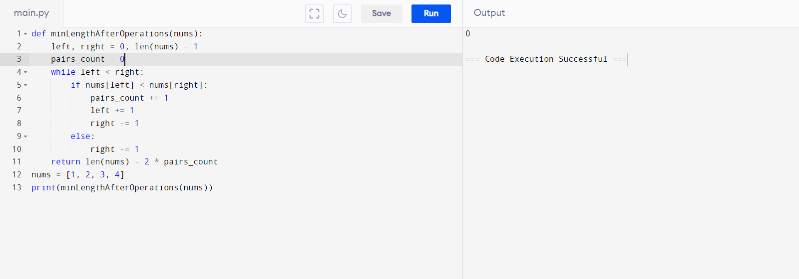

1. Given an array of string words, return all strings in words that is a substring of another word. You can return the answer in any order. A substring is acontiguous sequence of characters within a string

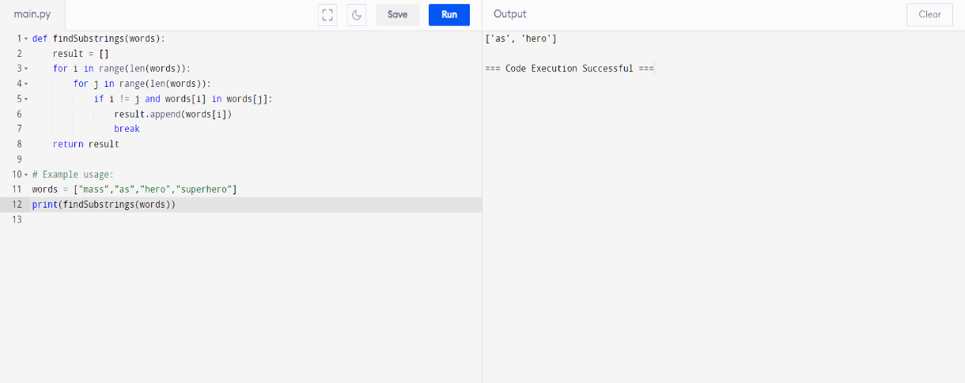

1. Given two integer arrays arr1 and arr2, return the minimum number of operations (possibly zero) needed to make arr1 strictly increasing. In one operation, you can choose two indices 0 <= i< arr1.length and 0 <= j < arr2.length and do the assignment arr1[i] = arr2[j]. If there is no way to make arr1 strictly increasing, return -1.

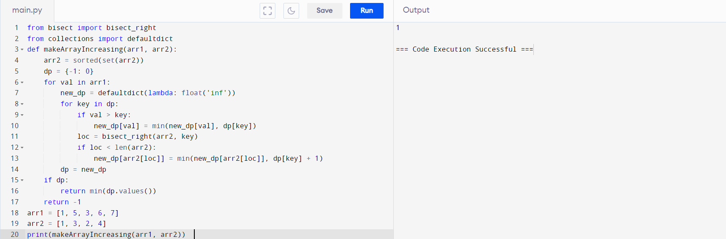

1. Given two strings a and b, return the minimum number of times you should repeat string a so that string b is a substring of it. If it is impossible for b​ to be a substring of a after repeating it, return -1. Notice: string "abc" repeated 0 times is "", repeated 1 time is "abc" and repeated 2 times is "abcabc".

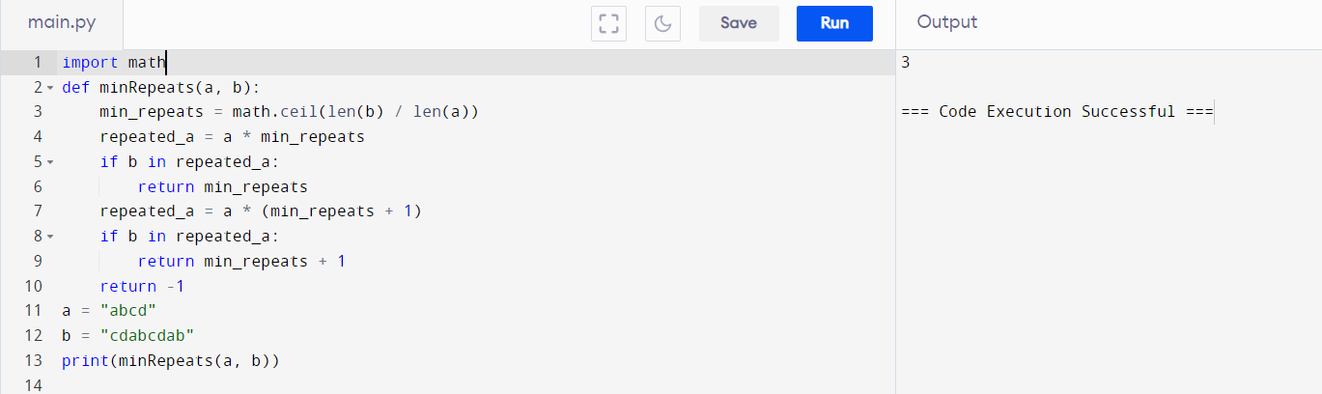

5.Given an array nums containing n distinct numbers in the range [0, n], return the onlynumber in the range that is missing from the array.

